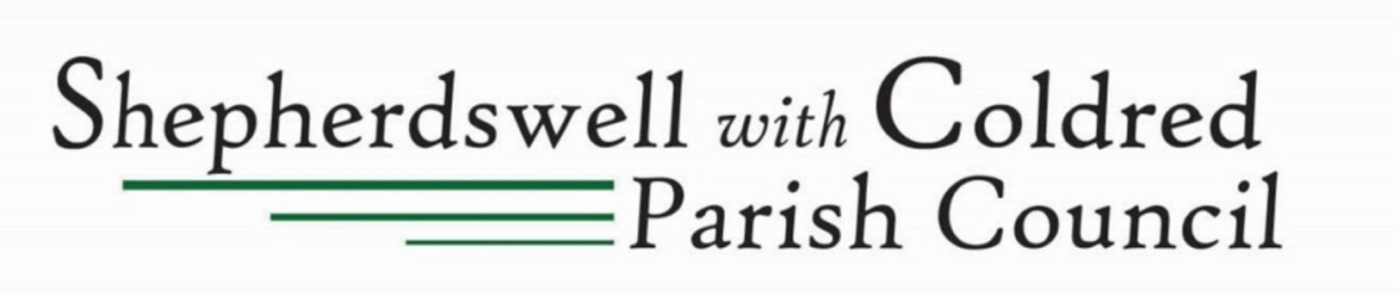

Parish Council Property Management
& Emergency Response Procedure

If there is immediate danger to life or property:
- Call Emergency Services (999)
- Notify Parish Clerk

All Other Property Issues
Always contact the Parish Clerk who will:
- Assess the situation
- Arrange necessary action
- Authorise repairs
- Manage reopening if facilities are closed

Urgent Issues (requiring same-day response) e.g. Flooding, structural damage, safety concerns
- Contact Parish Clerk immediately
- Do not attempt repairs

Non-Urgent Issues e.g. Minor repairs, maintenance
- Report to Parish Clerk for assessment
- Clerk will arrange inspection and repairs

Important
Only the Parish Clerk can authorise work on council property, this ensures repairs meet safety regulations and are of an accepted standard & cost.


Contact: Jan Rousell – Clerk/RFO
Phone: 07907 431837
Email: parishclerk@shepherdswellcoldred-pc.gov.uk

